Lab sheet 05

01)

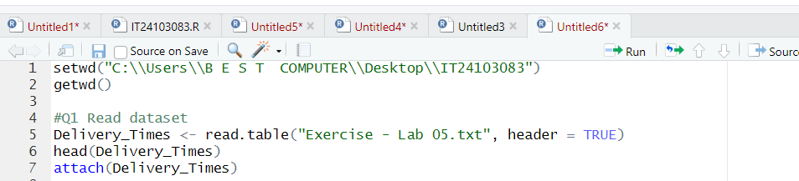

02)

03) The curve shows a bimodal distribution and appears

Approximately symmetrical. The data spans between 20 to 70 minutes.

04)

